Ideal Jobs

For my ideal job I want to be around other sociable people, I don’t want to be in a room by myself programming code and interacting with little to no people. I want to be in an environment where I feel comfortable in my own skin. I’ve heard through old reddit posts that Google was a great place to work, with great benefits, amenities and job security in a company that probably won’t close in the future! I would love to work for Google, although ideally in a perfect world I would have made my own company in my garage and become a billionaire like Jeff Bezos, but I could settle for working for Google, for example this job ad posted [here:](https://careers.google.com/jobs/results/129797672744690374-customer-success-manager-google-cloud/?company=Google&company=Google%20Fiber&company=YouTube&employment_type=FULL_TIME&hl=en_US&jlo=en_US&q=melbourne&sort_by=relevance/)

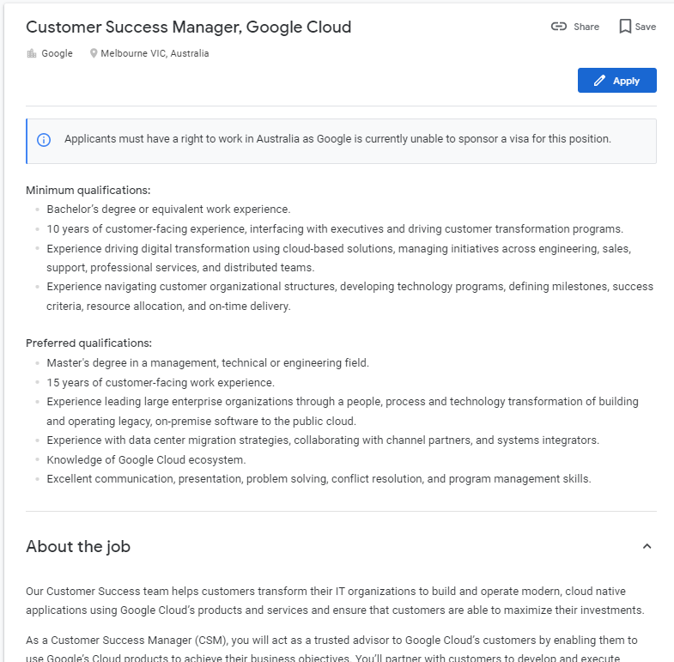 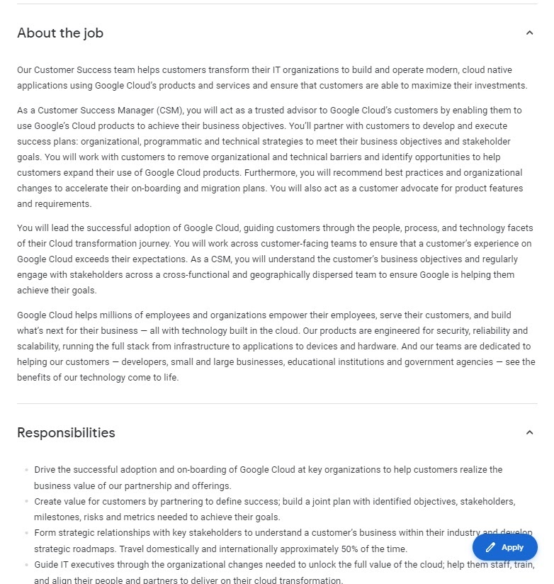 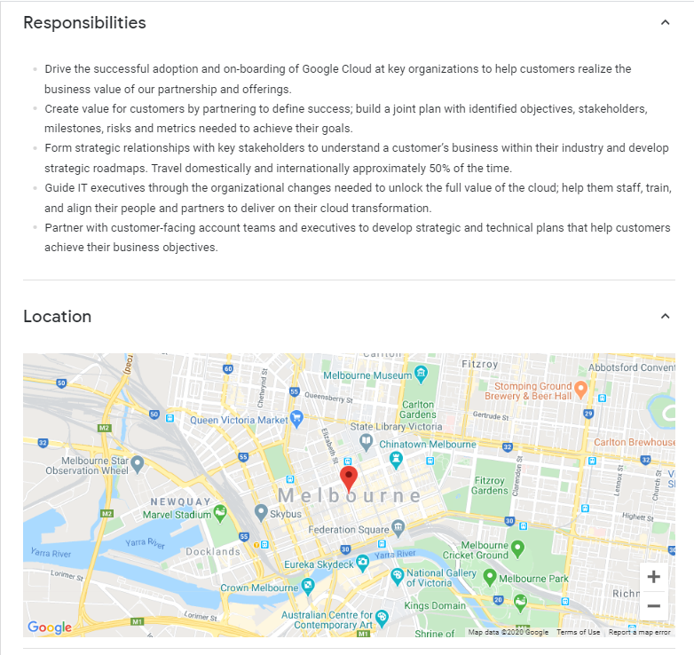

The job looks ideal to me because it combines I.T with the opportunity to interact with other people; both within the company among other employees and customers alike. This allows me to be sociable and interact with a wide variety of people as a manager. Not to mention I’m delegating work and looking at big picture things as a manager rather than focussing on small picture stuff as a specific programmer/designer etc. The job is also appealing because its located in the heart of Melbourne. Although it’s hard to know where I want to be in 5 years (if I end up being a genius in the I.T field) or 10 years’ time. As of right now, I think Melbourne, my home, is a good place to want to beâ€¦ with that being said, working at Google's HQ in sunny California would be amazing (given their gun laws change/trump isn’t president anymore)

Now I’ll be realistic however, there’s close to no chance I'll land this job coming out of RMIT as a graduate. Google is a massive company, one of the biggest in the world right now, and as a result this job requires a minimum of 10 years’ experience in the field. 10 years ago, I wasn’t even in high school yet. Google delivers quality services and they would want nothing but the best applicants to work for them. They won’t be hiring me anytime soon, but perhaps as an intern who gets everyone coffee? The job also requires experience in leading large enterprise organisations and a knowledge of Googles cloud ecosystem. It will be a long time before I meet the qualifications to work at Google or become a successful CEO like Jeff Bezos.

However, in the last line of preferred qualifications, it states that excellent communication, presentation, problem solving and conflict resolution. Based off my personality test, I am very sociable (I think so too), which means I do have relatively good communication skills. I also completed training in conflict resolution and currently hold a level 3 in restorative practice training, which means I am experienced in the topic. To elaborate I completed the training during my senior years at high school and then was given the opportunity to exercise those skills with accompanying teachers to help resolve issues among the junior students of my high school. Additionally, I currently work in customer service and have done so for a few years now and will probably do so for a few more years to come.

My plan to obtain the skills and experience required for the Google job ad or any job for that matter is to apply for everything that interests me, regardless of whether I do or don’t meet requirements. Interning for companies allows for me to practice and refine my skills I will learn at RMIT to real life situations. Like I said earlier, broadening my skills at RMIT as well, doing/learning about as many different things as I can in order to have experience in more fields to add flexibility for employers. If I can sell myself to a company as a programmer and a UX designer for example, how will 2 people compete with 1 person who can do both their jobs? Additionally, seeing as I work for JB HIFI, a tech-based company, who works with so many different companies, I could potentially use those connections to my advantage. Whether it be using my managers connections or interacting with representatives from companies we sell (e.g. Google/Apple/Samsung).